Blizzard in a Bag

February 5 snow day, due on March 14
Recycled Color Wheel
Haplea 8th Grade
Materials needed: scissors, paper, magazines, glue, altered book and any recyclable object.

Color wheel: An abstract illustrative organization of color hues around a circle that shows relationships between primary, secondary, intermediate and complementary colors.

Collage: A technique of art production, used in the visual arts, where the artwork is made from an assemblage of different forms, thus creating a new whole.

Day 2
41 minutes or more.

- Having done your primary colors, it is now time to do the same process with the secondary colors.

- Starting with the secondary colors, green, violet, orange, start cutting shapes and objects from magazines or recyclable objects. Glue these clippings to your base in an upside down triangular formation.

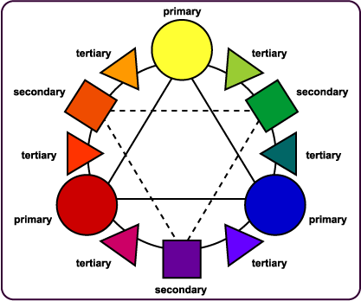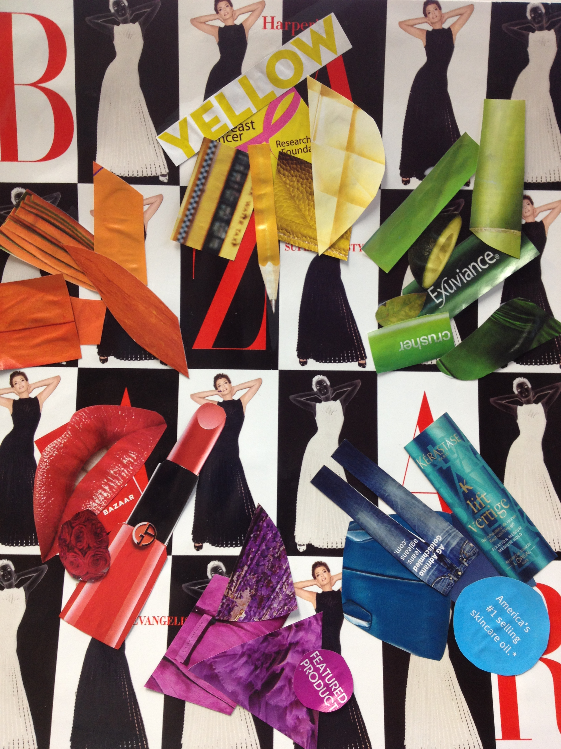

The second day is secondary colors only, clip five or more examples of each color and glue them down in the correct placement. Above is an example of the color wheel and my work in progress.

