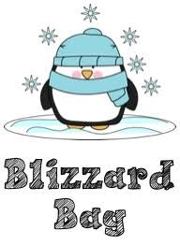
ART Blizzard Bag
DO ONE DRAWING FOR EACH SNOW DAY!

You may draw with a pencil or sharpie. You may shade with pencil or color with colored pencils too if you like.

Go to this website artprompts.org. Choose a category/prompt.
If you don’t have a computer or WiFi: Choose a prompt below and create a drawing.

CHARACTER
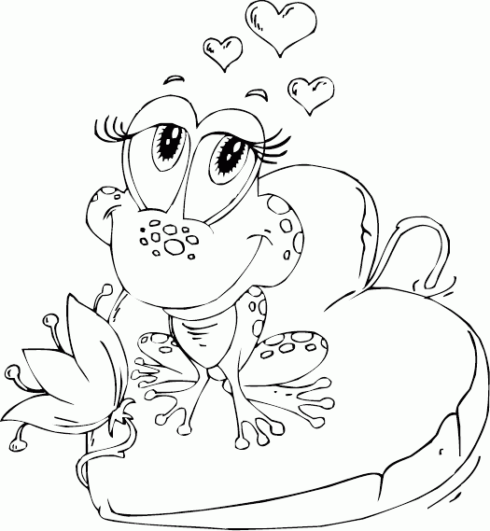
- Hippie
- Knight in Shining Armor
- Frog Prince
- Vampire at Dawn

CREATURE
- Draw a Monster mad of trash.
- Grim Reaper
- Cyclops girl
- An alien with fish-like, scaly skin

OBJECT
- Bird Skull
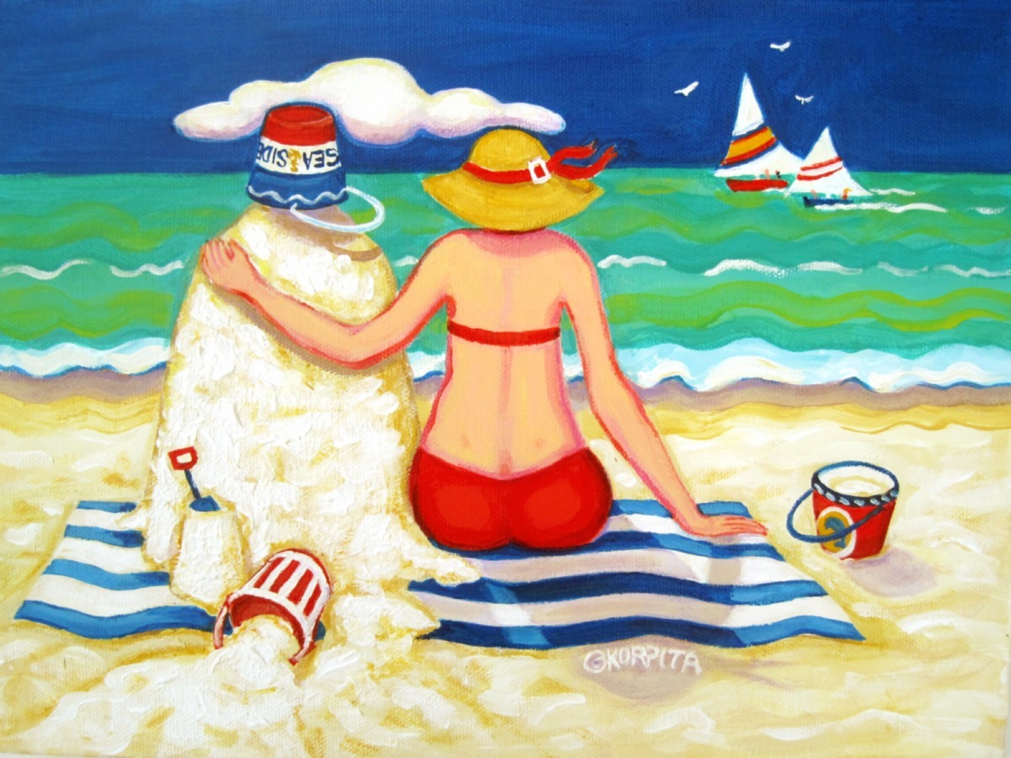
- Gas Mask
- Puppet Cat
- Snow Globe
- Space Ship

ENVIRONMENT
- Underwater treasure
- Space ship traveling through the universe
- A bugs life in the grass and plants
- Deserted island

SITUATIONS
- The darkness grabbed hold of him. Literally.
- Sasquatch sighting by two terrified campers
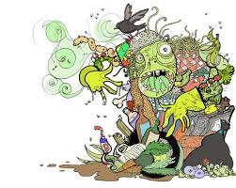
- It’s falling from the sky!
- Oh boy, this is my favorite! Thank you!
- Having lunch with a penguin
- Snowman at beach

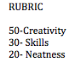
ILLUSTRATE Any NURSERY RHYTHM (choose a line and bring it to life)
- Old women in a shoe
- 3 little pigs
- Little teapot

Choose a Song and create a drawing- BE INSPIRED

