Blizzard Bag #1: K-2 Art, Music, Physical Education

- Select a piece of music that you have access to at home and create a dance and/or fitness routine to an adult in the household. List the title of the song below.
- Select a contrasting piece of music and draw a picture describing how the music makes you feel and share the picture with an adult in the household. List the title of the song below and attach the picture.

Student signature: _______________________________________________

Song Title for #1: _______________________________________________

Song Title for #2: _______________________________________________

Parent signature: _______________________________________________

Blizzard Bag #2: Music, Grade 1

Rhythm

- Find two pencils or sticks in your home to tap together.
- Using the worksheets “Pease Porridge Hot” and “Naughty Kitty Cat,” tap the rhythm using “Ta,” “Ti-Ti,” and “Rest” (“Ta” is the straight line and “Ti-Ti” is the joined lines. The “Z” is a rest.) I have included the words for “Pease Porridge Hot” below to help you.
- Create 2 rhythms below and tap them out with your pencils. Put four beats in each measure. Remember, “Ta” equals one beat. “Ti-Ti” also equals one beat, but makes two sounds. A rest equals one beat but makes no sound.

Pease Porridge Hot (rhyme)

Pease porridge hot, pease porridge cold,
Pease porridge in the pot, nine days old.

My rhythms:

Rhythm #1 (4 beats in each measure):

Rhythm #2 (4 beats in each measure):

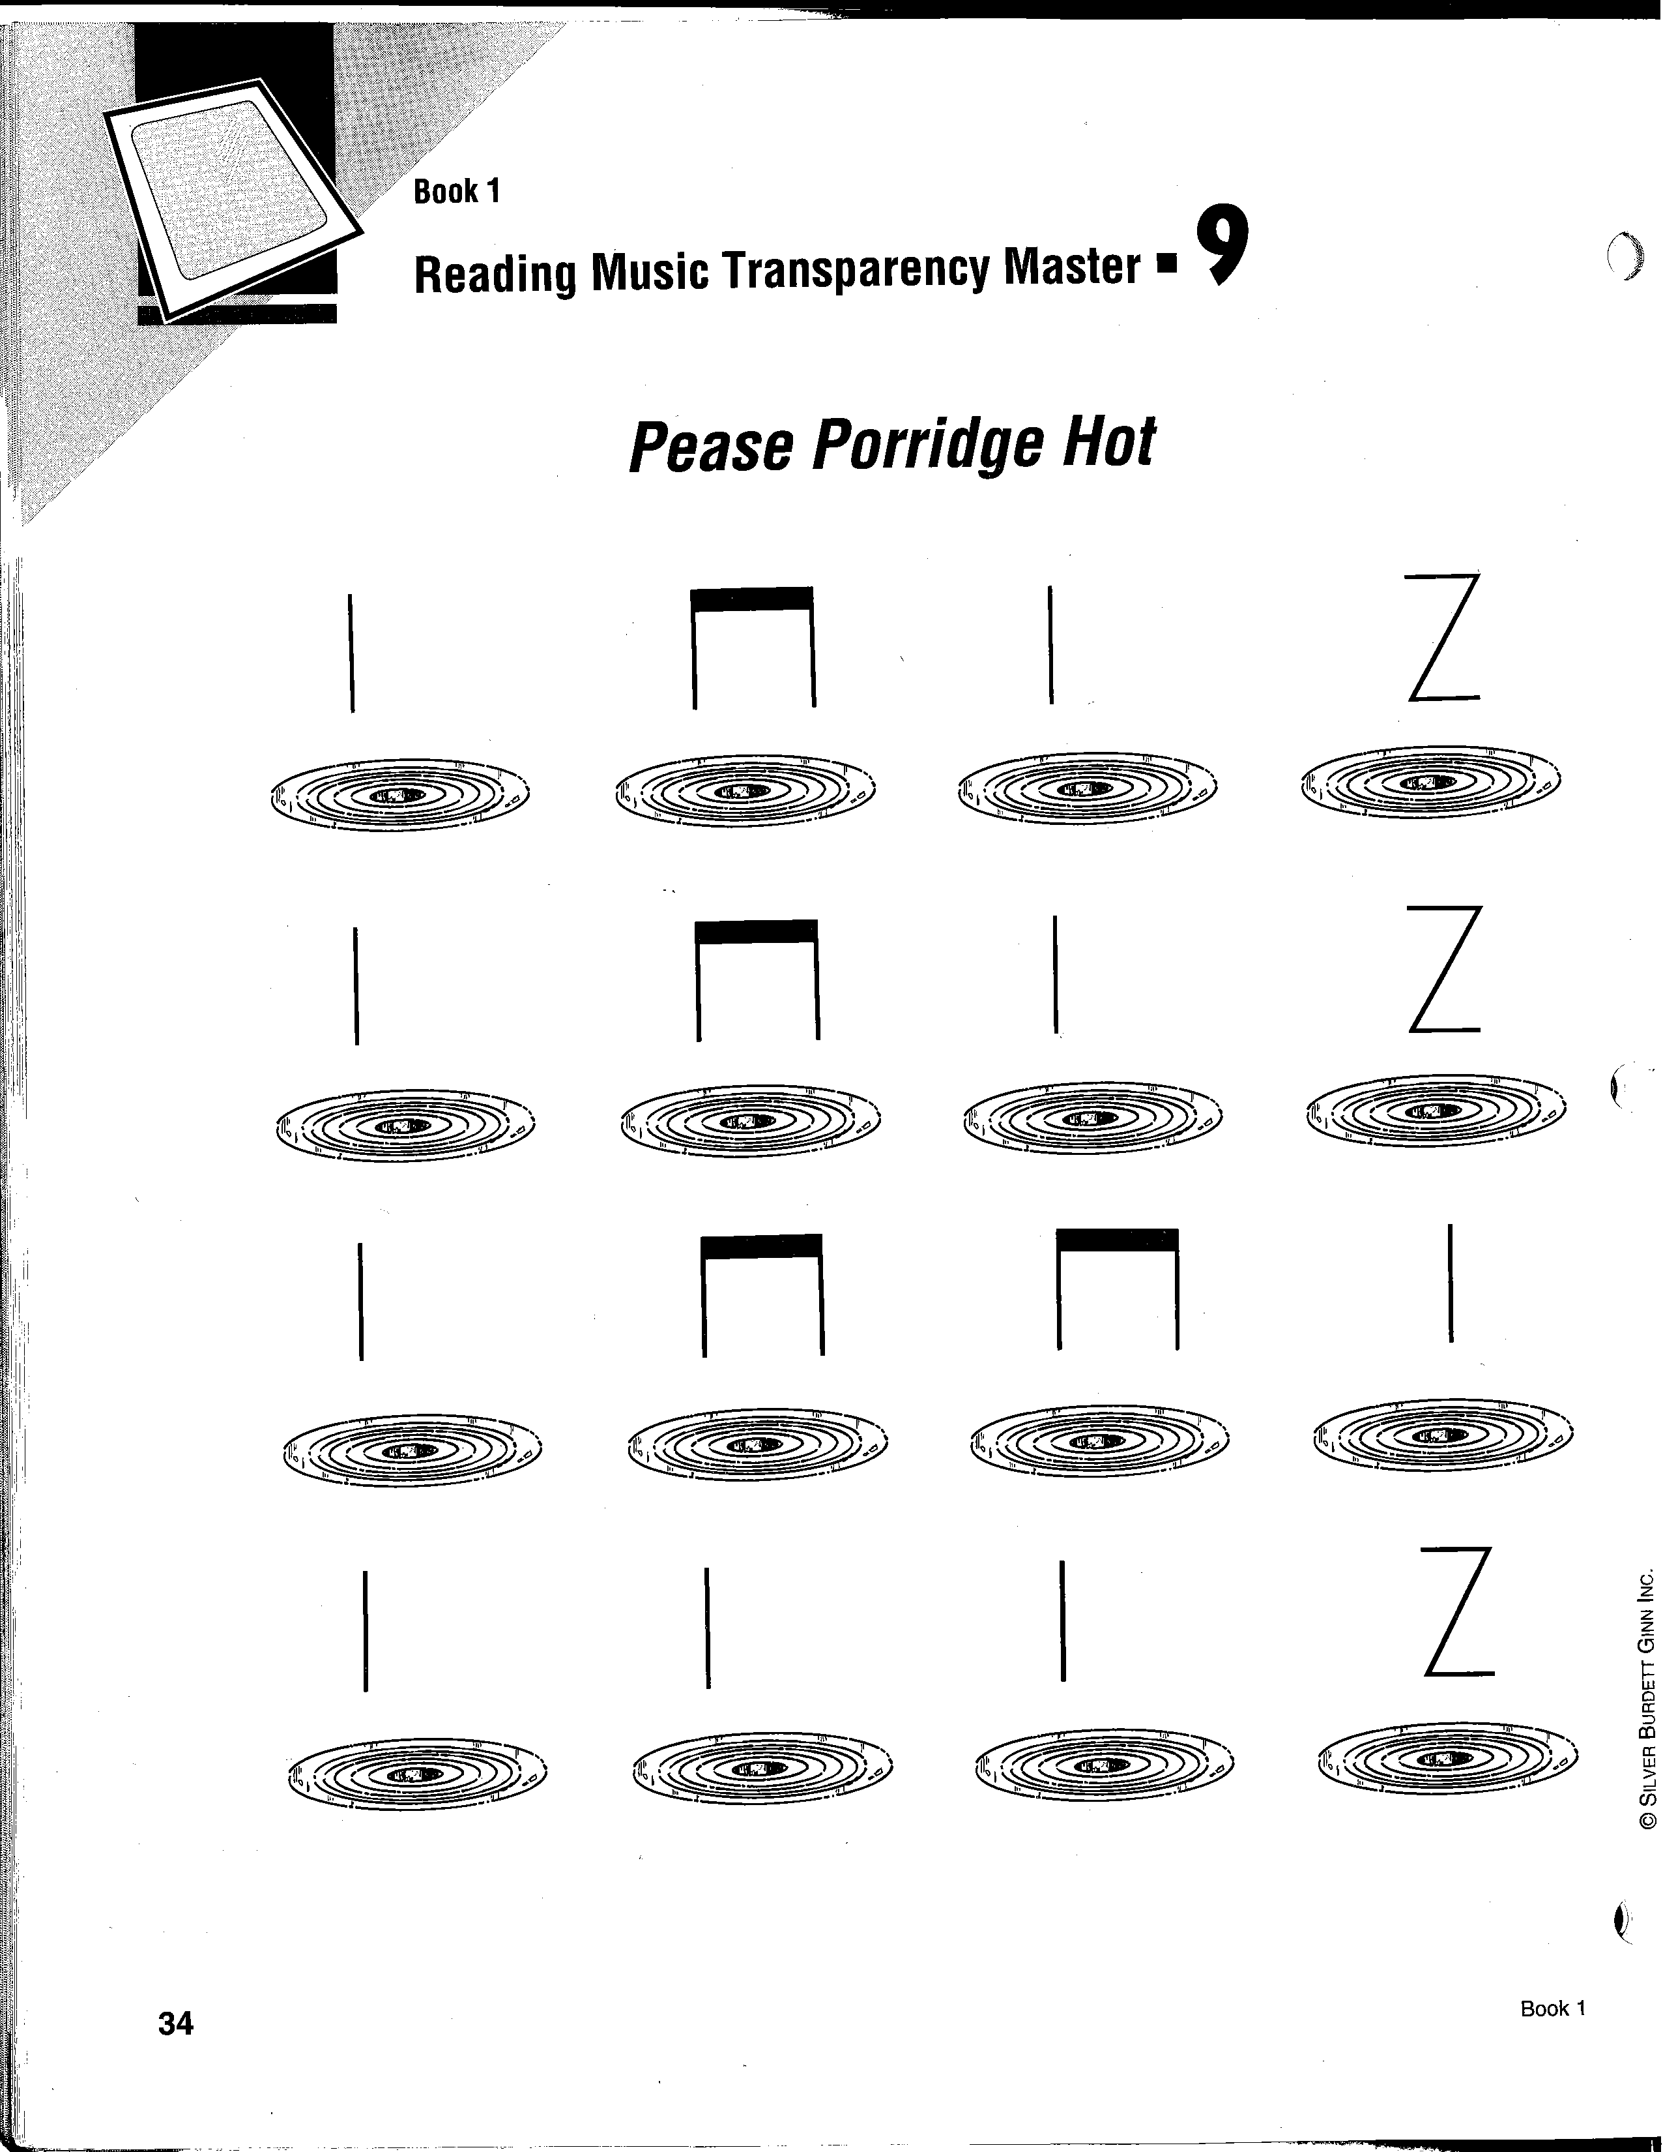

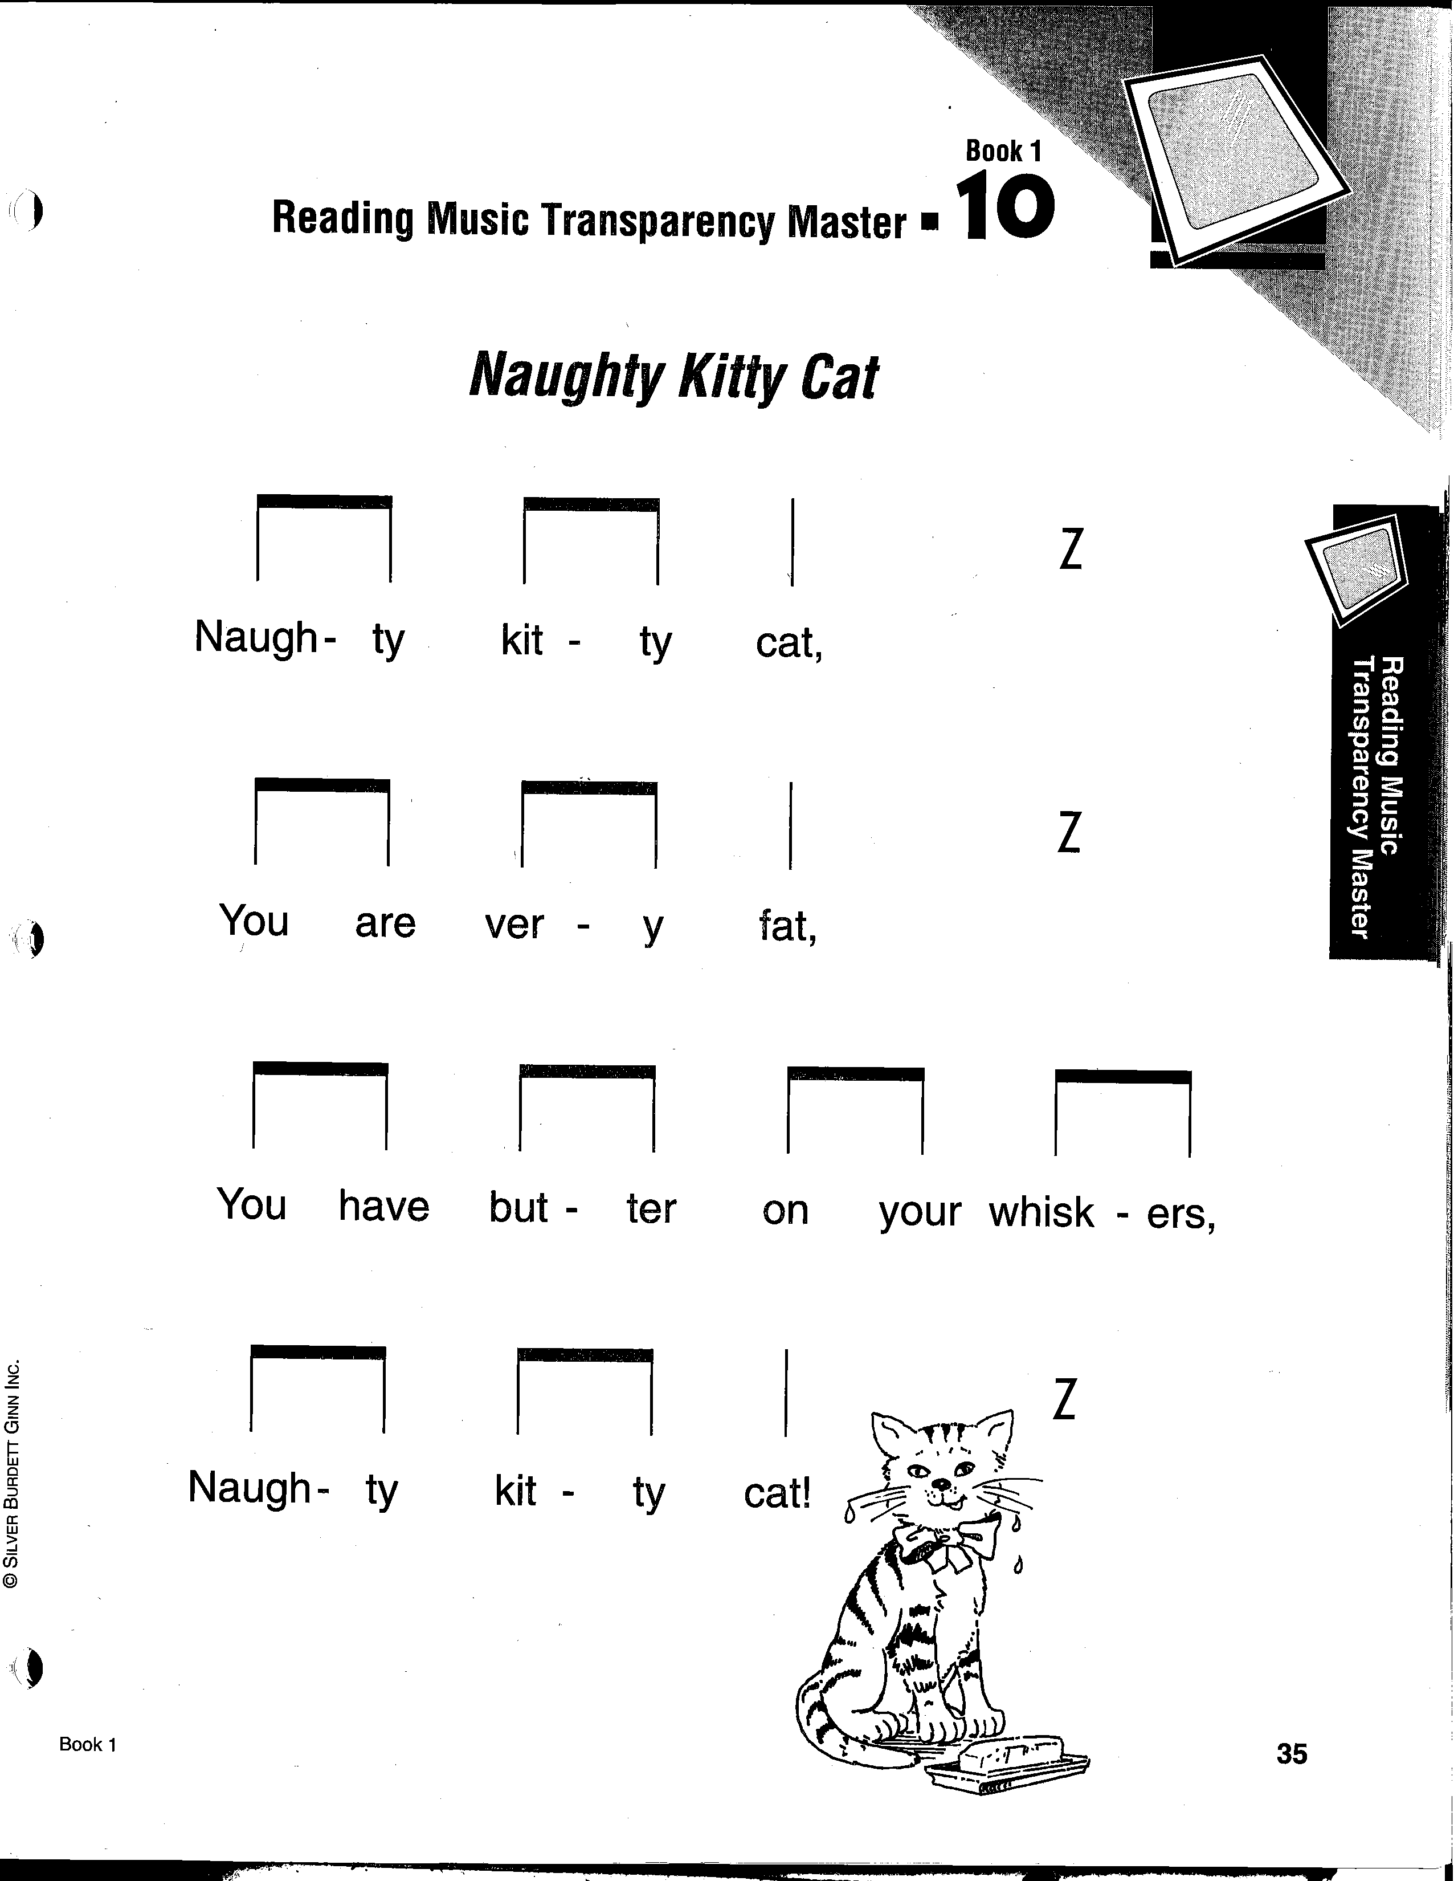

Blizzard Bag #3: Music, Grade 1

Rhythm

- Find two pencils or sticks in your home to tap together.
- Using the worksheet “Lucy Locket,” tap the rhythm using “Ta” and “Ti-Ti.” (“Ta” is the straight line and “Ti-Ti” is the joined lines.)
- Look at the worksheet “Pease Porridge Hot.” This time, we’re using a repeat sign. You will tap the same rhythm this time, but there are more words to the rhyme. I’ve included the rhyme below.
- Create a rhythm of your own using “Ta,” “Ti-Ti” and Rest. Use the same rhythm in each line that begins with a triangle and a different rhythm for the line with the square.

Pease Porridge Hot (rhyme)

Pease porridge hot, pease porridge cold,
Pease porridge in the pot, nine days old.
Some like it hot, some like it cold,
Some like it in the pot, nine days old.

